Claude Code Skills: The Complete Guide (That Most Developers Still Don’t Understand)
Imagine if you could teach AI your workflow once and never repeat instructions again.
No re-prompting. No re-explaining context. No starting from scratch.
That’s exactly what Claude Code Skills enable.
Most developers still treat AI like a smart assistant.
But the real power comes when you turn it into a trained specialist.
Press enter or click to view image in full size

Claude Code Skills: The Complete Guide
In this guide you’ll learn how to build Claude Skills that automate workflows, standardise outputs, and unlock true AI productivity.
🔔 Follow Me: Medium | GitHub | Linkedin | Join Community

Table of Contents
- Introduction: Stop Prompting AI — Start Training It
- The Problem With Traditional AI Workflows
- What Claude Code Skills Actually Are
- How Claude Skills Work Under the Hood
- The Three Types of Claude Skills
- Designing Your First Claude Skill
- Testing and Improving Your Skills
- Five Advanced Patterns Used by Top Builders
- Common Mistakes (And How to Avoid Them)
- How to Share and Distribute Your Skills

1. The Problem With Using AI the Old Way
I remember the first time I thought I had “figured out” AI.
I had this long prompt saved in a notes app. It was beautifully structured with bullet points, instructions, formatting rules, and examples. Whenever I wanted Claude to generate something (code, docs, UI layouts), I’d paste that prompt and watch the magic happen.
For a while, it felt powerful.
Then the cracks started showing.
Every new conversation meant copy → paste → tweak → resend.
If I forgot one line from the prompt, the output changed.
If the model interpreted a sentence differently, the results drifted.
At first I blamed the AI.
But eventually I realised the problem wasn’t the AI.
It was how I was using it.

The Prompt Loop
My workflow started to look something like this:
- Paste a giant prompt
- Clarify the output format
- Fix the formatting
- Add missing steps
- Re-explain context
Then repeat the same thing the next day.
And the next.
And the next.
It was like training a new intern every single conversation.
Press enter or click to view image in full size
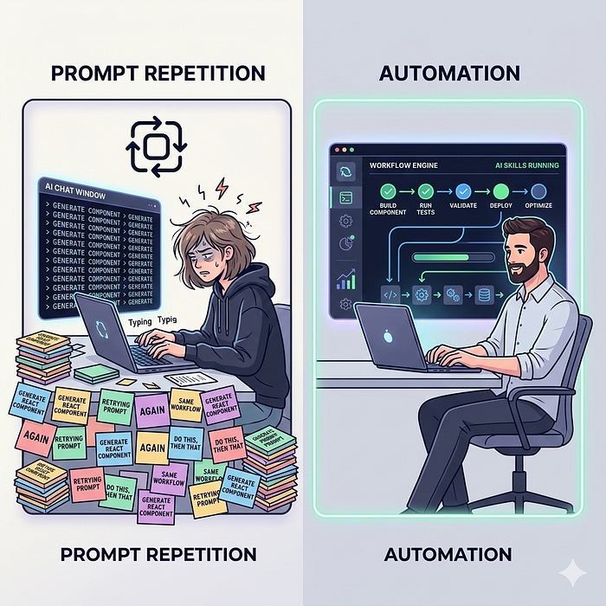
Frustrations, Repetitions, and Inconsistency vs Automation and Consistency

The Frustrations Every Developer Eventually Hits
If you’ve been using AI seriously for development, you’ve probably run into some of these too.
Repeating instructions every conversation
I had to explain the same rules again and again:
“Follow this design style.”
“Use this architecture.”
“Generate output in this format.”
Even though the instructions never changed.
Inconsistent outputs
One day the AI would generate exactly what I wanted.
The next day?
Different structure.
Different tone.
Different approach.
Nothing technically wrong, just… not consistent.
When you’re building real systems, that inconsistency becomes painful.
Workflows breaking mid-process
Some tasks required multiple steps:
- research
- analyze
- generate
- validate
- refine
But halfway through, the context would drift.
Or the model would skip a step entirely.
I found myself constantly nudging it back on track.
Team members prompting differently
This one surprised me the most.
When teammates started using AI for the same workflows, everyone wrote their prompts differently.
Some prompts were detailed.
Some were vague.
Some skipped key steps.
Which meant the results across the team were wildly inconsistent.
Not ideal when you’re trying to standardise processes.

The Moment It Clicked
One evening I was fixing yet another AI output that went off track.
And I caught myself thinking:
“Why am I re-teaching this workflow every time?”
That’s when the realisation hit me.
Prompts are temporary.
They only exist for that one conversation.
The moment the chat ends, the knowledge disappears.

Skills Change the Game
Instead of telling the AI what to do every time, you teach it once.
The workflow becomes reusable.
The instructions become structured.
And the AI automatically activates the skill when it recognises the situation.
Press enter or click to view image in full size
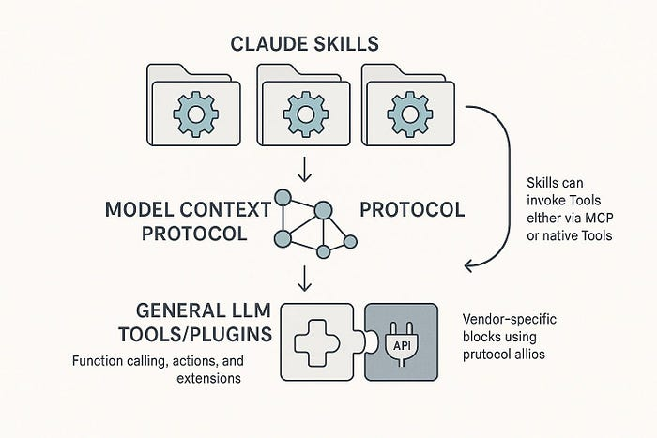
Claude Skills for Every Context [Coding, UI, Testing, etc]
The best way I’ve heard it described is this:
Prompts are conversations.
Skills are capabilities.
Or in simpler terms:
Skills = reusable AI workflows
Once I started building skills, something interesting happened.
The AI stopped feeling like a chat assistant…
…and started feeling like a trained teammate.

My Advice to You
If you’re serious about using AI for real work — not just experiments — try this simple shift in thinking:
Instead of asking:
“What prompt should I write?”
Start asking:
“What workflow should I teach the AI?”
Then turn that workflow into a skill.
Let me give you complete guide on Cluade Skills for your Projects and Work.

2. What Claude Skills Actually Are?
At its core, a Claude skill is surprisingly simple.
It’s just a folder that teaches Claude how to perform a specific workflow.
Instead of repeating instructions in every conversation, you package your workflow once. Claude can then automatically recognise when to use that workflow and apply it consistently.
Think of it like creating a mini playbook for AI.
Instead of telling Claude:
“First analyze this… then generate output… then validate formatting…”
…you encode those instructions inside a skill so Claude can execute them automatically.
Press enter or click to view image in full size
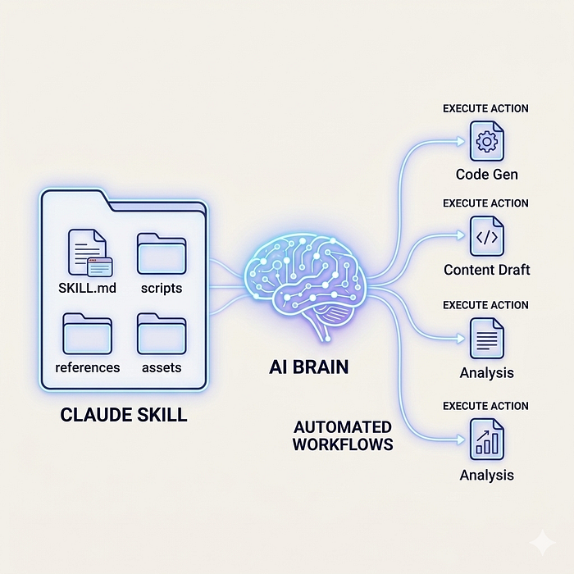
What Claude Skills are?

The Core Components of a Claude Skill
A skill follows a simple folder structure.
your-skill-name/
├── SKILL.md
├── scripts/
├── references/
└── assets/
Each part serves a different purpose.

1. SKILL.md — The Brain of the Skill
This is the most important file.
SKILL.md contains:
- the skill metadata (YAML frontmatter)
- instructions on how the workflow works
- examples and troubleshooting
Example frontmatter:
---
name: frontend-design
description: Creates high-quality frontend UI components. Use when building web pages, UI elements, or web applications.
---
This metadata tells Claude when the skill should activate.
Tip for you:
The description must include:
- what the skill does
- when it should be used
Otherwise the skill may never trigger automatically.

2. scripts/ — Optional Automation Code
Some workflows require real computation or validation.
The scripts/ folder allows you to include executable scripts such as:
- Python
- Bash
- automation utilities
Example:
scripts/
├── validate_data.py
└── generate_report.sh
Use cases:
- validating uploaded data
- processing datasets
- formatting outputs
- running checks before generating results
Practical tip:
If a step must be deterministic, use a script instead of relying purely on language instructions. Code ensures reliability.

3. references/ — Documentation and Knowledge
This folder contains supporting information Claude can consult when needed.
Examples:
references/
├── api-guide.md
├── style-guide.md
└── examples/
Typical content:
- API documentation
- company style guides
- workflow guidelines
- example outputs
Best practice:
Keep the main SKILL.md concise and move large documentation here to avoid large context issues.

4. assets/ — Templates and Files
The assets folder stores reusable files.
Examples:
assets/
├── report-template.md
├── slide-template.pptx
└── design-icons/
These are useful when the skill generates:
- reports
- presentations
- UI layouts
- documents
Templates ensure consistent output quality.

Why This Structure Matters?
Claude Skills follows a design principle called progressive disclosure.
Instead of loading everything at once:
- Frontmatter metadata loads first
- Full instructions load only when needed
- References and files load on demand
This reduces token usage while preserving specialised knowledge.

Real Examples of What Skills Can Do
Claude Skills are most powerful when applied to repeatable workflows.
Some common use cases include:

Frontend UI generation
A skill can:
- read design specs
- apply your design system
- generate production-ready components
For example:
User: "Create a landing page hero section"
Skill automatically:
1. Applies brand style guide
2. Uses predefined layout structure
3. Generates HTML + CSS
Result: consistent UI across projects.

Project planning workflows
A project management skill might:
- Fetch project status
- Analyze team capacity
- Prioritize tasks
- Create tickets in Linear
Result: a fully structured sprint plan.

Automated research pipelines
A research skill could:
- collect sources
- analyze information
- synthesize insights
- generate structured reports
This turns Claude into a repeatable research assistant.

Document generation systems
Skills can standardise document creation:
Examples:
- reports
- presentations
- technical documentation
For example:
User: "Create a quarterly business report"
Skill automatically:
• applies company formatting
• includes required sections
• validates data
• produces final document
Result: professional documents every time.

One More Important Detail
Claude Skills are portable.
Once created, they work across:
- Claude.ai
- Claude Code
- API-based systems
You build the skill once, and it can run in multiple environments.

Practical Tips for Building Your First Skill
Here are a few lessons directly from the guide:
1. Start with 2–3 concrete use cases
Avoid building overly broad skills.
Example:
Good:
“Generate frontend UI from design specs”
Bad:
“Help with development”
2. Keep instructions clear and structured
Use:
- numbered steps
- bullet points
- examples
Claude follows structured instructions more reliably.
3. Include trigger phrases in the description
Example:
description: Creates sprint plans and task lists. Use when user asks "plan sprint", "create tasks", or "organize project backlog".
This improves automatic skill activation.

The Big Idea
Claude Skills turn AI from something you talk to into something you configure.
Instead of writing better prompts…
You build repeatable systems that Claude can execute reliably.
And once you start thinking in workflows instead of prompts, AI becomes much more powerful.

3. The Secret Architecture Behind Skills
One of the smartest design choices behind Claude Skills is something called Progressive Disclosure.
Instead of loading the entire skill into context every time, Claude loads only what it needs, when it needs it.
This keeps responses fast, reduces token usage, and still allows skills to contain large amounts of expertise.
Skills work in three layers.
Press enter or click to view image in full size
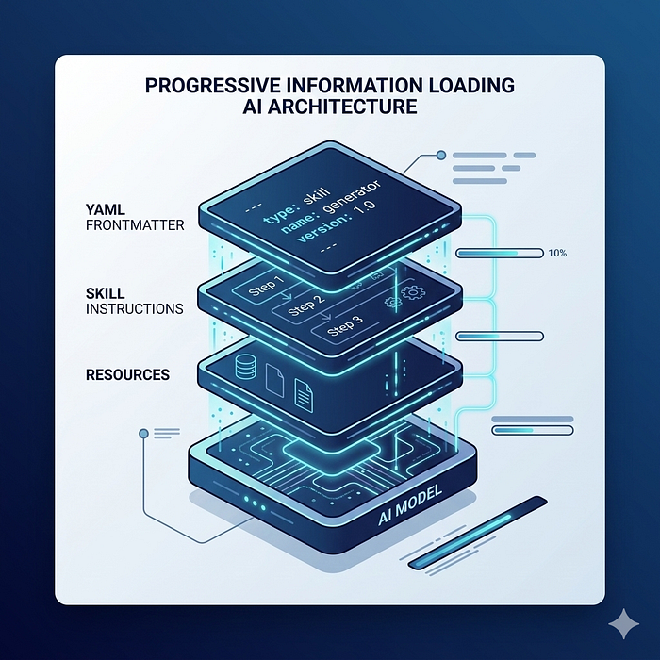
Secret Architecture Behind Skills: Progressive Disclosure

Layer 1: YAML Frontmatter (Always Loaded)
The YAML frontmatter sits at the top of the SKILL.md file and is always loaded into Claude’s system prompt.
It defines:
- skill name
- description
- trigger phrases
Example:
---
name: frontend-design
description: Generate high-quality frontend UI components. Use when building web pages, UI layouts, or web components.
---
This layer acts like a discovery system.
Claude reads this metadata and decides:
“Should I activate this skill for the user’s request?”
Example:
User says:
“Create a responsive hero section for my landing page.”
Claude sees the phrase “create UI” and activates the frontend-design skill.

Layer 2: Main Instructions (Loaded When Relevant)
If Claude decides the skill is relevant, it loads the main instructions inside SKILL.md.
These instructions contain the actual workflow steps.
Example:
Step 1: Analyze design requirements
Step 2: Apply brand style guide
Step 3: Generate HTML and CSS components
Step 4: Validate responsiveness
This layer tells Claude how to execute the task properly.

Layer 3: Linked Resources (Loaded On Demand)
The third layer includes supporting files inside the skill folder.
Examples:
- documentation in references/
- scripts in scripts/
- templates in assets/
Example workflow:
If the skill needs an API rule, Claude may open:
references/api-patterns.md
If it needs validation, it may run:
scripts/validate_data.py
These resources are only accessed when necessary, keeping the system efficient.

Why This Architecture Matters
Without progressive disclosure, every skill would load thousands of tokens into context.
With it, Claude only loads:
- metadata first
- instructions when needed
- resources only if required
The result:
- faster responses
- lower token usage
- more scalable skill systems
In short, progressive disclosure lets Claude behave like a specialist without carrying the entire manual in memory.

4. The 3 Types of Claude Skills Everyone Should Know
After analysing many real-world implementations, most Claude Skills fall into three main categories.
Understanding these patterns helps you design better and more focused skills.
Press enter or click to view image in full size
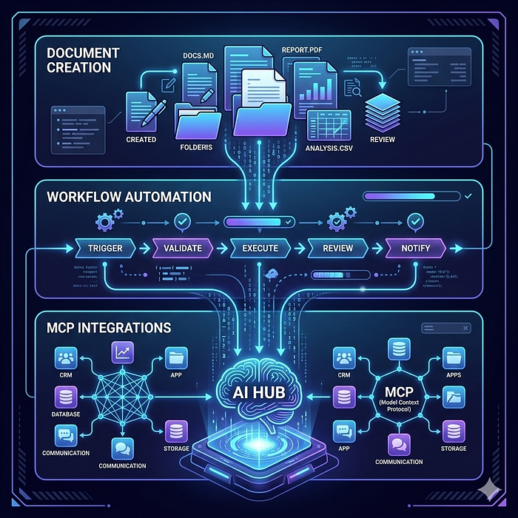
3 Types of Claude Skills Everyone Should Know

1. Document & Asset Creation Skills
These skills focus on generating consistent, high-quality outputs.
They are commonly used for creating:
- UI components
- reports
- presentations
- documentation
- design artifacts
Example:
A frontend-design skill could generate production-ready UI.
User request:
“Create a responsive dashboard layout.”
The skill automatically:
- applies your design system
- uses predefined layout templates
- generates structured HTML + CSS
Key techniques used in these skills:
- embedded style guides to enforce brand standards
- templates for consistent formatting
- quality checklists before finalizing output
Result: consistent outputs without manual formatting every time.

2. Workflow Automation Skills
These skills automate multi-step processes that normally require several manual actions.
Example: Sprint Planning Automation
Workflow:
- fetch project status from Linear
- analyze team velocity and capacity
- prioritize tasks
- create tickets with labels and estimates
Result:
A fully planned sprint created automatically.
These skills usually include:
- step-by-step workflows
- validation checks
- automated tool calls
They’re ideal for repeatable operational tasks.

3. MCP Enhancement Skills
These skills enhance integrations built with Model Context Protocol (MCP).
MCP connects Claude to external tools like:
- Notion
- GitHub
- Linear
- Slack
But MCP only gives access to tools.
Skills teach Claude how to use those tools effectively.
The guide explains it with a simple analogy:
ClaudeSkillsGuide
MCP provides the kitchen.
Skills provide the recipes.
Example:
A code-review skill might:
- fetch GitHub pull requests
- analyze errors from Sentry
- suggest fixes
- generate a review summary
Without the skill, users must manually guide each step.
With the skill, Claude automatically performs the full workflow.

Quick Tip for Builders
When designing your first skill, decide which category it fits into:
- generating outputs → Document Skills
- automating processes → Workflow Skills
- guiding tool usage → MCP Skills
This clarity makes your skill simpler, more reliable, and easier for Claude to trigger correctly.

5. How to Design a Powerful Skill (The Framework)
The most common mistake developers make is starting with code instead of the workflow.
A good Claude Skill begins with clear task design, not implementation.
Here’s a simple framework from the guide to design reliable skills.
Press enter or click to view image in full size

Framework to Design a Powerful Skill in Claude Code.

Step 1: Define Clear Use Cases
Start by identifying 2–3 specific tasks your skill should handle.
Example:
Use Case: Sprint Planning
Trigger phrases
- “plan this sprint”
- “create sprint tasks”
Workflow
- fetch project data
- analyze team capacity
- prioritize tasks
- create tickets
Tip: Include real phrases users would say in the description so the skill triggers automatically.

Step 2: Define Success Metrics
A strong skill should be measurable and reliable.
Good indicators include:
- triggers on most relevant queries
- requires minimal user corrections
- completes workflows with fewer API calls
- produces consistent results across sessions
Example test:
Run the same request 3–5 times and check if the output structure remains consistent.

Step 3: Design the Folder Structure
Claude Skills follow a simple structure.
Example:
your-skill/
├── SKILL.md
├── scripts/
├── references/
└── assets/
- SKILL.md → instructions and metadata
- scripts/ → automation or validation code
- references/ → documentation
- assets/ → templates and resources
Tip: Keep SKILL.md focused on the workflow and move detailed documentation to references/ to avoid large context usage.

Quick Tip
Before building a skill, ask yourself:
“What exact workflow am I trying to automate?”
Clear workflows lead to skills that trigger correctly, run reliably, and require less prompting.

6. My Figma-Cluade Code Skill That Actually Works
The most important part of any Claude Skill is the YAML frontmatter.
Why? Because this is how Claude decides whether the skill should activate or not.
If the description is vague, the skill might never trigger, even if it’s perfectly built.
Press enter or click to view image in full size
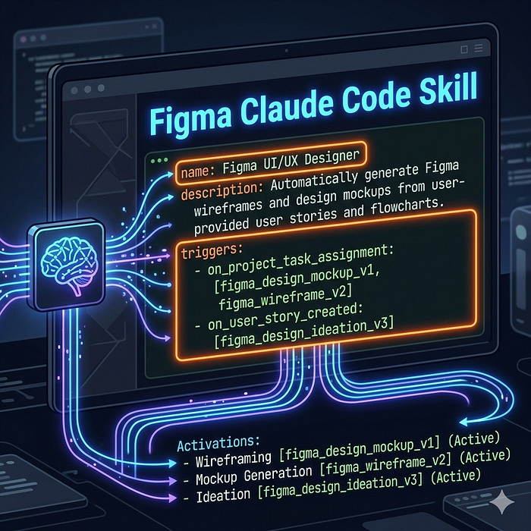
My Figma-Cluade Code Skill That Actually Works

What the Frontmatter Does
The YAML frontmatter sits at the top of SKILL.md and includes key metadata like:
- skill name
- description
- trigger conditions
Example structure:
---
name: figma-handoff
description: Analyzes Figma design files and generates developer handoff documentation. Use when user asks for design specs, component documentation, or uploads .fig files.
---
This tells Claude exactly when to load the skill.

Good vs Bad Skill Descriptions
Strong description (specific triggers)
Analyzes Figma design files and generates developer handoff documentation. Use when user asks for design specs, component documentation, or uploads .fig files.
Why this works:
- explains what the skill does
- includes real user phrases
- references file types
Weak description
Helps with projects.
Problems:
- too vague
- no trigger phrases
- unclear purpose
Claude cannot determine when this skill should run.

Simple Tip for Better Skills
When writing the description, always include:
1. What the skill does
2. When to use it
3. Example user phrases
Formula:
[What it does] + [When to use it] + [Example triggers]
Example:
Generates structured research reports from multiple sources. Use when user asks to “analyze research papers”, “summarize studies”, or “generate literature review”.
Clear triggers dramatically improve automatic skill activation and reliability.

7. How to Test Your Skill Properly
Building a skill is only half the job. The other half is testing whether it actually works reliably.
The guide recommends testing skills at three levels.
Press enter or click to view image in full size

How to Test Your Skill Properly?

1. Trigger Testing
First, verify that the skill activates at the right time.
Test different user prompts and see whether the skill loads automatically.
Example tests:
Should trigger
- “create sprint plan”
- “help me organize sprint tasks”
- “plan tasks for this sprint”
Should NOT trigger
- “write a poem”
- “explain JavaScript closures”
Tip: Test 10–20 variations of prompts to ensure the skill triggers correctly in real conversations.

2. Functional Testing
Next, check whether the skill performs the workflow correctly.
Verify:
- outputs are accurate
- API calls succeed
- edge cases are handled
- error messages are clear
Example test:
Task:
Create project “Q4 Planning” with 5 tasks.
Expected result:
- project created
- 5 tasks added
- tasks correctly linked
- no API errors

3. Performance Testing
Finally, compare results with the skill vs without the skill.
Example comparison:
Without skill
- 10–15 back-and-forth messages
- multiple corrections
- higher token usage
With skill
- 1–2 clarifying questions
- automated workflow
- fewer errors
- lower token usage
Start by perfecting one task before expanding the skill. Once Claude reliably completes that workflow, you can add more scenarios and edge cases.

8. The 5 Advanced Skill Patterns
Once you understand the basics, most powerful Claude Skills follow a few proven design patterns. These patterns help handle complex workflows more reliably.
Here are five commonly used ones.
Press enter or click to view image in full size

5 Advanced Skill Patterns

Pattern 1: Sequential Workflow
In this pattern, tasks must run in a strict order.
Each step depends on the previous one.
Example: Customer onboarding pipeline
Workflow:
- create customer account
- set up payment method
- create subscription plan
- send welcome email
Tip: Always include validation checks between steps so the workflow doesn’t continue if something fails.

Pattern 2: Multi-MCP Coordination
Some workflows involve multiple external tools. Skills can coordinate them in sequence.
Example pipeline:
Figma → Drive → Linear → Slack
Workflow:
- export design assets from Figma
- store assets in Google Drive
- create development tasks in Linear
- notify the engineering team on Slack
Tip: Clearly define data passing between tools (e.g., asset links from Drive added to Linear tasks).

Pattern 3: Iterative Refinement
Some outputs improve with multiple improvement cycles.
The workflow looks like:
generate → validate → refine → repeat
Ideal for:
- research reports
- data analysis
- documentation
Example:
- generate report draft
- validate structure and data
- fix missing sections
- regenerate improved version
Tip: Define a clear stopping condition, such as “no validation errors”.

Pattern 4: Context-Aware Tool Selection
Here, the skill decides which tool to use based on context.
Example: Smart file storage
Decision logic:
- large files → cloud storage
- documents → collaborative workspace
- code → Git repository
Tip: Include fallback options in case the preferred tool fails.

Pattern 5: Domain Intelligence
This pattern embeds specialized expertise inside the skill.
Example: Financial compliance checks
Workflow:
- analyze transaction details
- apply compliance rules
- check sanctions lists
- approve or flag transaction
Tip: Always perform validation or compliance checks before executing actions.
Most advanced skills combine multiple patterns. For example, a workflow might use:
- sequential steps
- multiple MCP tools
- iterative refinement
Understanding these patterns helps you design more reliable and scalable AI workflows.

9. Common Skill Problems (And How to Fix Them)
Even well-designed Claude Skills can run into issues. Most problems come from small configuration mistakes or unclear instructions. Here are the most common ones and how to fix them.
Press enter or click to view image in full size

Common Skill Problems and their Fixes

1. Skill Doesn’t Upload
Cause: The most common reason is a file naming error.
Claude requires the main file to be named exactly:
Common mistakes:
- skill.md
- SKILL.MD
- Skill.md
These will cause the upload to fail.
Fix: Ensure the file is exactly SKILL.md (case-sensitive) inside the skill folder.

2. Skill Never Triggers
Sometimes the skill works but never activates automatically.
Cause: The description in the YAML frontmatter is too vague.
Example (bad):
Helps with projects.
Claude doesn’t know when to use it.
Fix: Improve the description with clear triggers and tasks.
Example:
Creates sprint plans and task lists. Use when users say “plan sprint”, “create tasks”, or “organize backlog”.
This helps Claude recognize when the skill should activate.

3. Skill Triggers Too Often
Sometimes the opposite happens — the skill loads even when it shouldn’t.
Cause: The description is too broad.
Example:
Processes documents.
This might trigger for almost any request.
Fix: Add specific scope and negative triggers.
Example:
Processes PDF legal documents for contract review. Do NOT use for general document editing.
This narrows the activation conditions.

4. Instructions Are Ignored
Another common issue is when Claude loads the skill but doesn’t follow the instructions correctly.
Cause
- instructions too long or unclear
- critical rules buried in text
- relying only on language instructions
Fix
Improve instruction clarity:
- simplify instructions with bullet points
- highlight critical steps (e.g., “CRITICAL: validate inputs first”)
- use validation scripts for deterministic checks
Example:
Instead of writing:
Validate data before proceeding.
Write:
CRITICAL:
Before creating a project verify:
- project name is not empty
- start date is valid
- at least one team member is assigned

Quick Tip
If something isn’t working, ask Claude:
“When would you use this skill?”
Claude will repeat the description triggers, which helps you identify what’s missing or unclear.

10. How to Distribute and Share Your Skills
Once your skill is working, the next step is making it accessible to others.
The current distribution method is simple.
Press enter or click to view image in full size

How to Distribute and Share Your Skills?

Basic Installation Workflow
Most users install skills using this process:
- create the skill folder
- compress it as a .zip file
- upload it in Claude
In Claude.ai, you can upload it through:
Settings → Capabilities → Skills
Once uploaded, Claude can automatically activate the skill when relevant requests appear.

Deploying Skills for Teams
For organizations, skills can also be deployed workspace-wide.
This allows teams to:
- standardize workflows
- maintain consistent AI outputs
- push updates centrally
Example:
A company might deploy skills for:
- sprint planning
- document generation
- customer onboarding
So every team member gets the same automated workflow.

Best Strategy for Sharing Skills
If you want others to use your skill, the recommended approach is to host it publicly.
A common setup:
Host the skill on GitHub
This makes it easy for developers to download, modify, or contribute.
Provide a clear README
Your README should explain:
- what the skill does
- when to use it
- installation steps
- example outputs
Screenshots help users understand the value quickly.
- Include a simple installation guide
Example:
1. Clone the repository
2. Download the skill folder
3. Zip the folder
4. Upload it in Claude → Settings → Skills
Clear instructions reduce friction and increase adoption.
When sharing skills, focus on outcomes rather than technical details.
Instead of saying:
“This is a YAML-based AI skill.”
Say:
“This skill automatically generates production-ready UI components from design specs.”
People adopt skills faster when they immediately understand the benefit.

Final Thoughts
Claude Skills unlock a powerful shift in how we work with AI.
You stop prompting AI every time…
and start training AI to follow your workflows.
Instead of repeating instructions, you package knowledge once and reuse it across projects, teams, and conversations.
That’s a big change.
It moves AI from being just a chat assistant to becoming a reliable system that executes structured tasks.
And the developers who understand this early will have a huge advantage.
They won’t just be writing better prompts.
They’ll be building AI workflows, tools, and systems that scale far beyond a single chat window.
If you want to start today, don’t overthink it.
Pick one repetitive task you already do with AI.
Maybe it’s:
- generating reports
- creating UI components
- planning project tasks
- analyzing research
Then turn that workflow into your first skill.
Once you experience the difference between prompting AI and training AI, it’s hard to go back.

